ECS webserver container

ECS (Elastic Container Service)

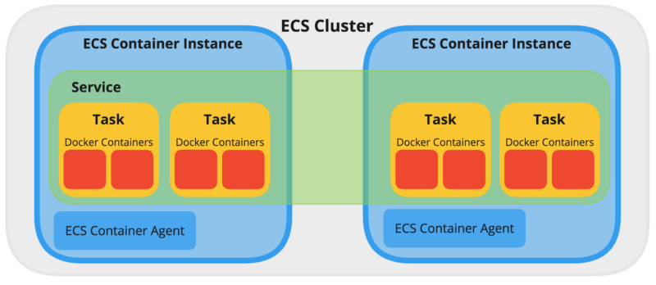

Using ECS we will create a container on AWS without using the commands

To create a ECS we need EC2 instance

Cluster means group of Ec2 instances

ECS automatically creates instances

If we create container manually in case the container gets down again, we should create the container manually

Just we create containers on ECS it will manage the containers, it will check make sure the containers are running are not

In ECS we call container as task

In cluster we give configuration (Ec2 configuration)

Task definition means container definition

First, we create cluster

In cluster we have Ec2 instances

Service

In it We have container Task definition – task definition specifies the container information for application how much resource are use like that

Container Task

Step one open your AWS and got ECS and create a cluster and select Ec2 Linux machine

Here we have ECS agent which is called the Default container which manage all the container in the cluster

Step one create a cluster for our best practice here I am creating a EC2 Linux + Networking

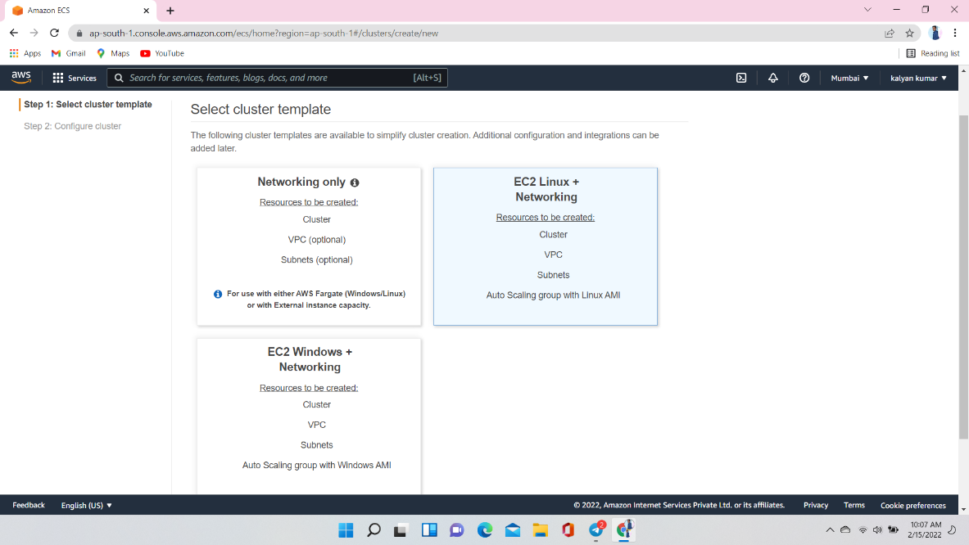

After the selection of cluster template provide cluster name

Instance configuration:- Provisioning Model is on-Demand instance

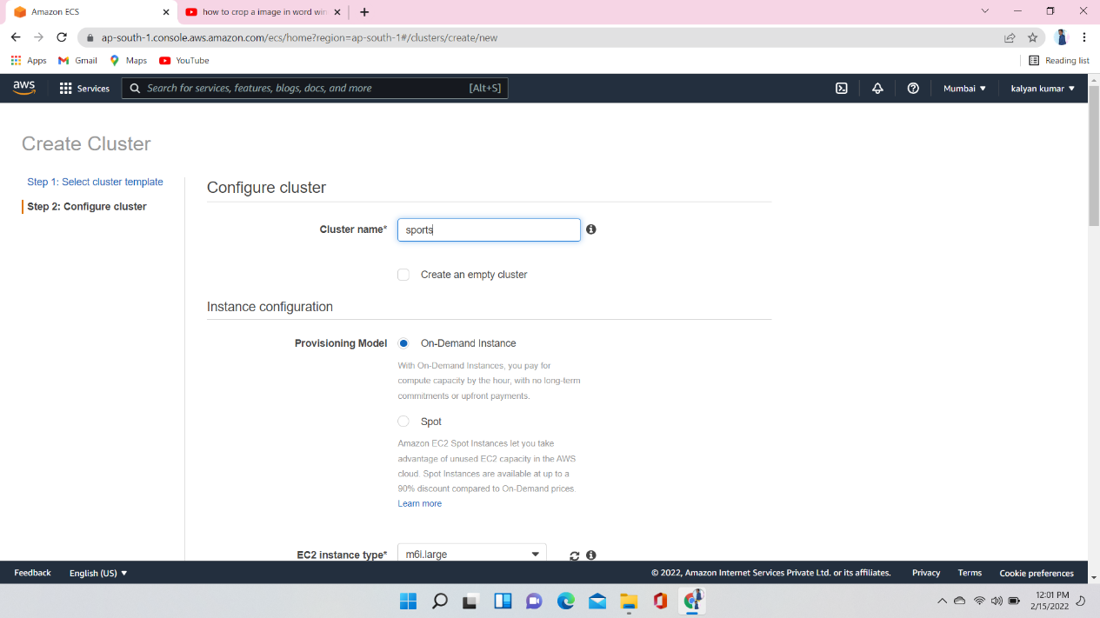

Select instance type her and give number of instance you want and EC2 AMI Id also and Key pair

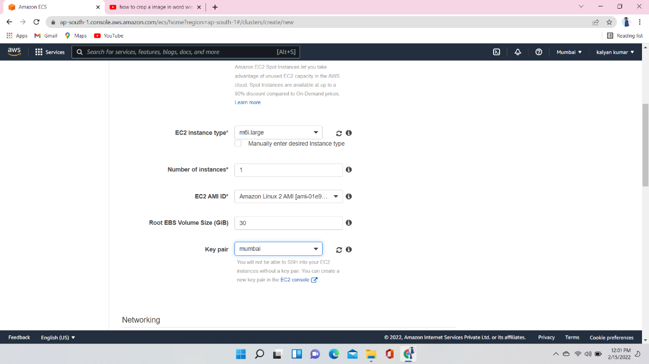

Here you should create one VPC and two Subnets

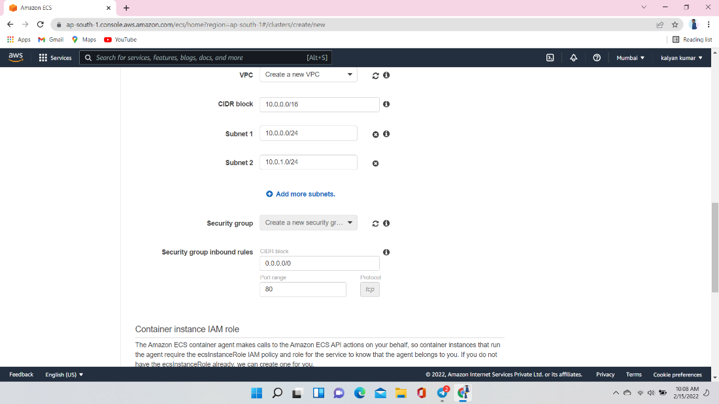

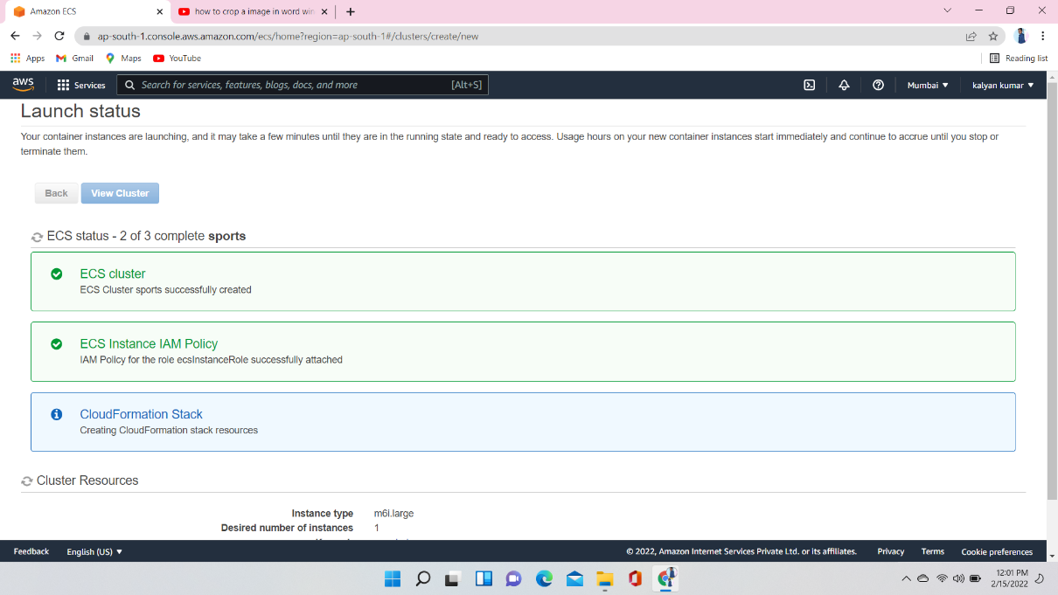

Create task Definition

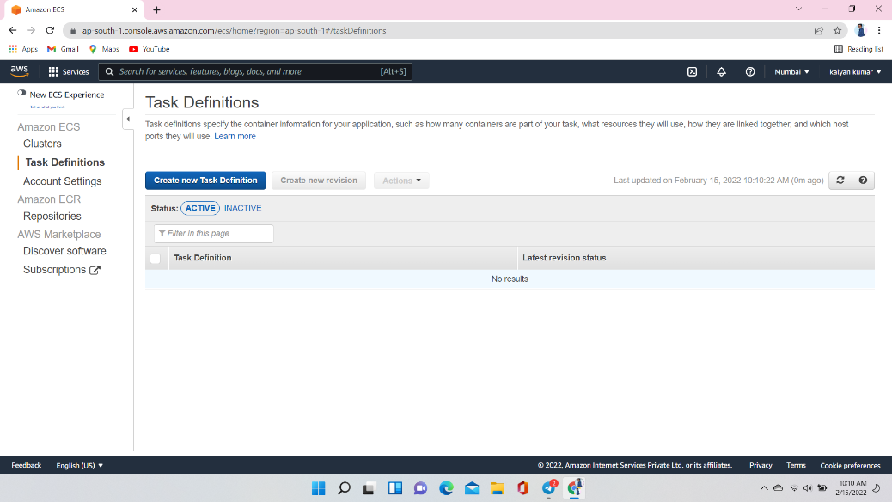

Select laund type compatibility as EC2

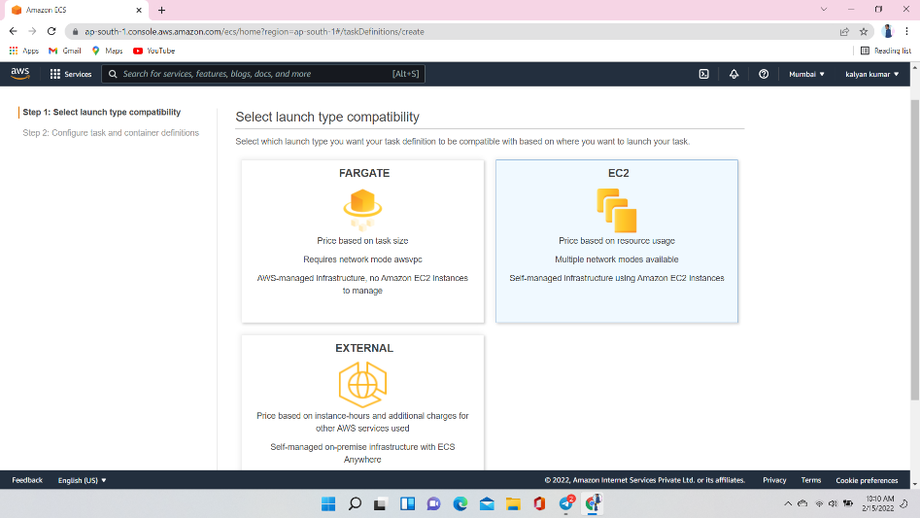

Configure task and container definition

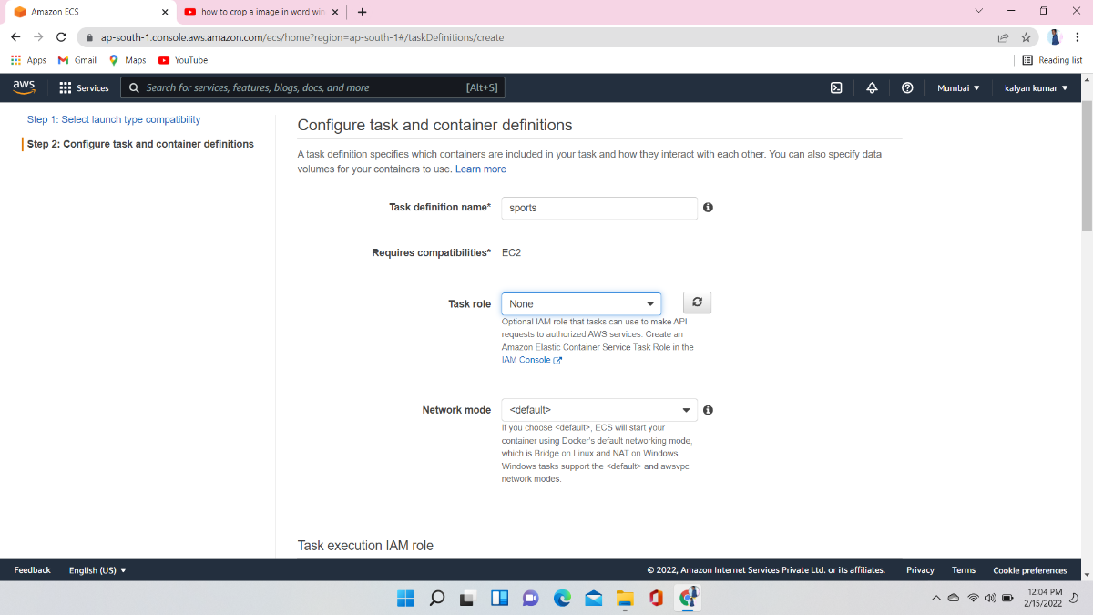

Here you give size

Ram and hard disk … here I was give hard disk 800mb and ram 256

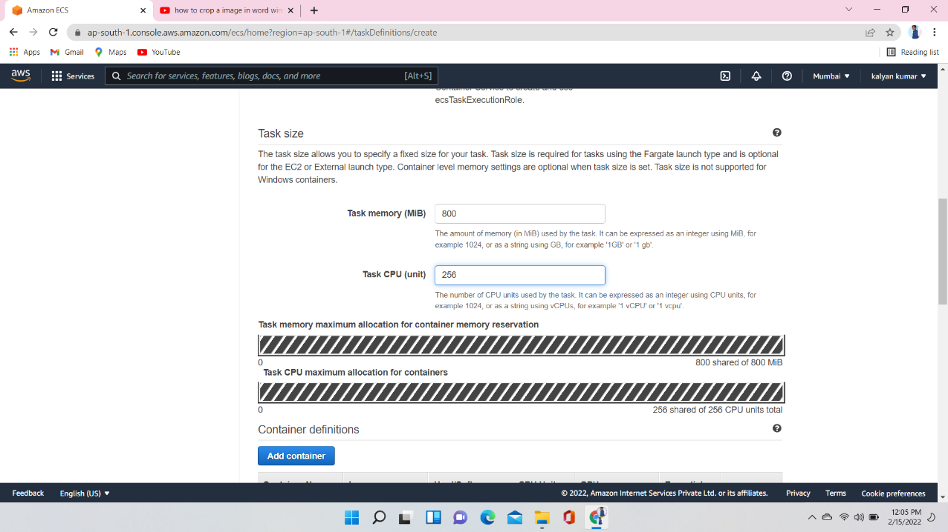

Add container and give container name and container image and port mapping

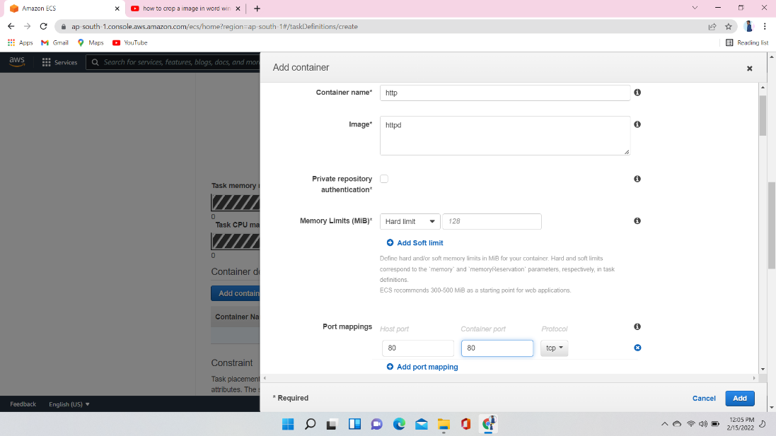

Create a Service as EC2 and provide number of tasks and service name

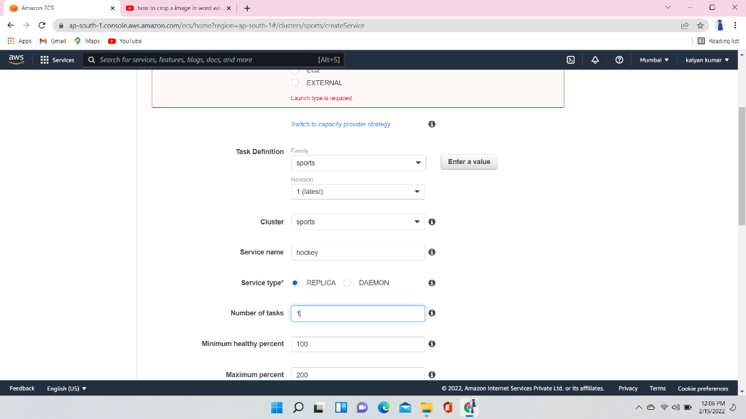

Auto Scalling

It will automatically adjust your services desired count up and downwithin a specified range in response to cloudWatch alarms

If we select second option in the picture we have to manage them manually

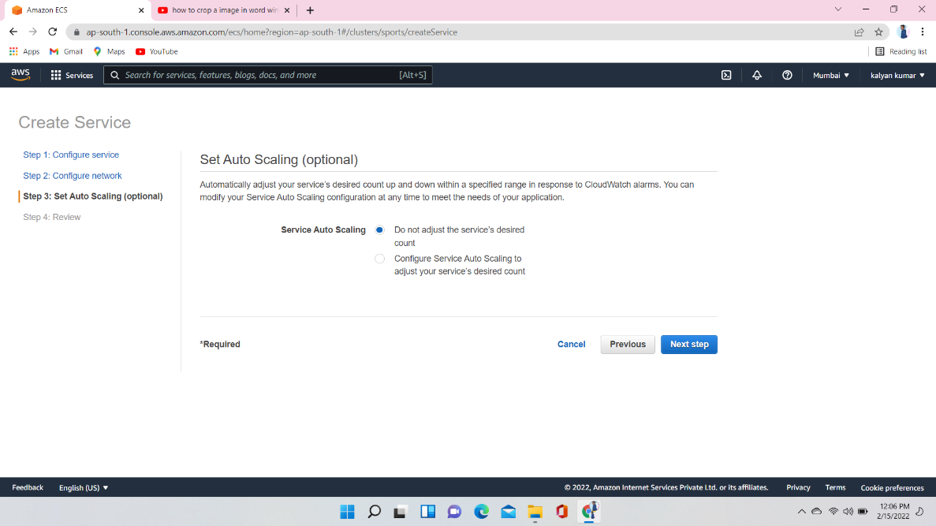

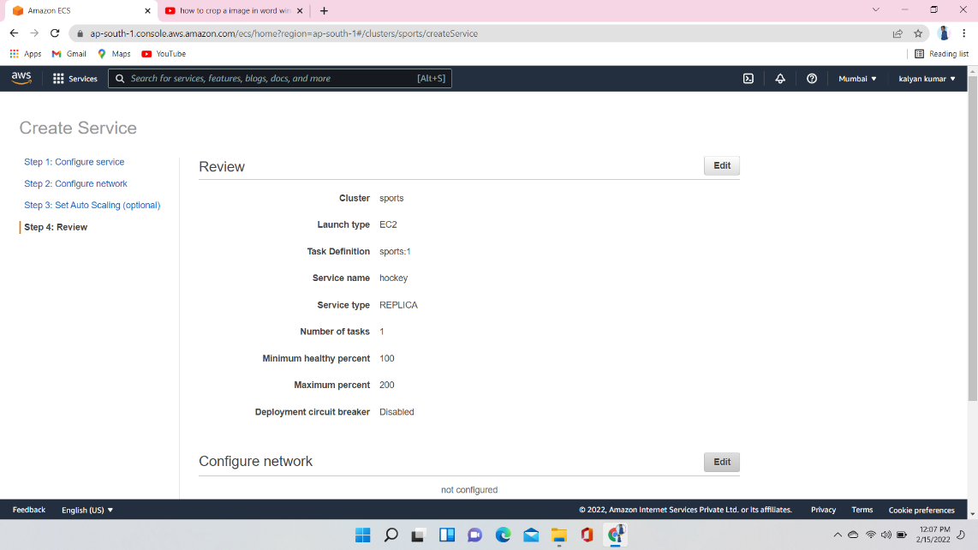

Here service and task created

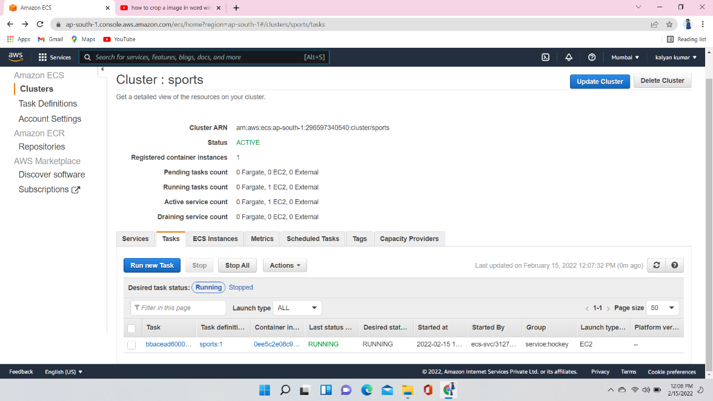

Here one instance is created and it has docker with it

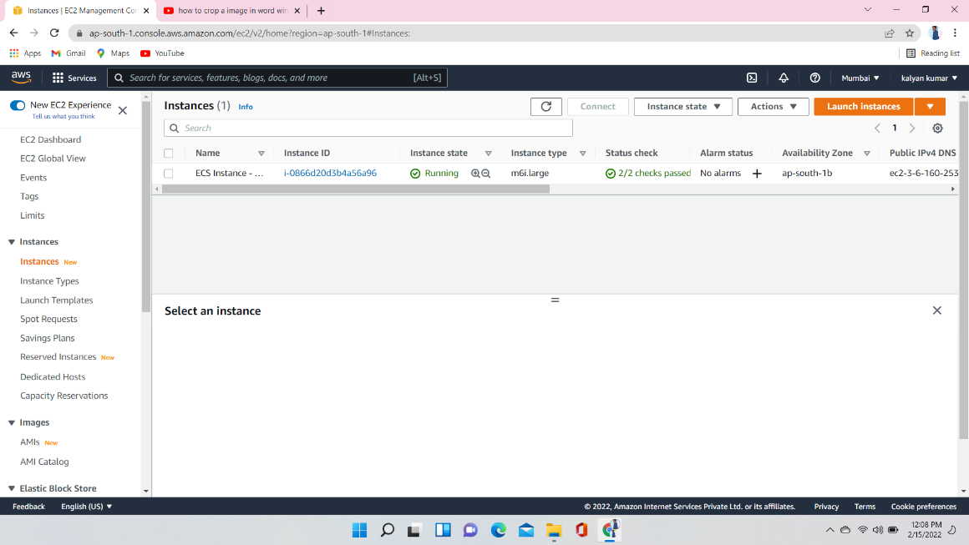Conect instance to t

Connect instance to the terminal and check the images and containers

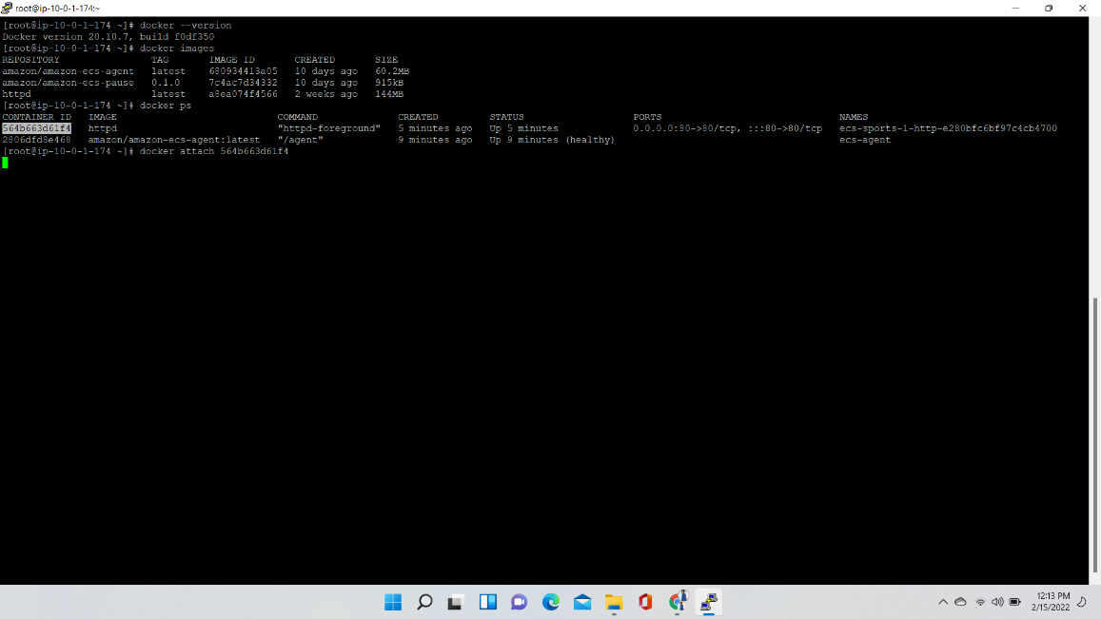

Take instance public IP and check it was working are not

